May Notes: Day 4 Overhunting and Invasive Species
Name: Period: Date:
Aim: What would happen if an ecosystem becomes unbalanced?
Objectives:
- Identify the consequences of Invasive species to an ecosystem
- Describe ways in which humans can cause the ecosystem to be unbalanced
Do Now: List 2 ways in an ecosystem can be unbalanced?

What does over hunting do to an ecosystem?
- and are very and . If something to one of the in the chain, it the entire chain.
- In normal / relationships, a exist because of the of both the population and the
- When a population kills than it needs it is called
- can occur to any in the food chain (including plants).
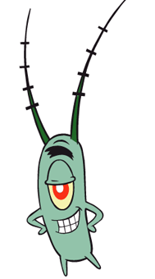
- the top predators in a food chain can upset the balance of a food chain.
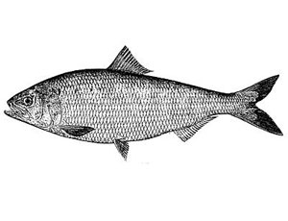
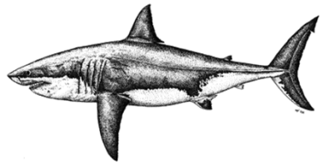
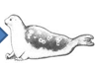
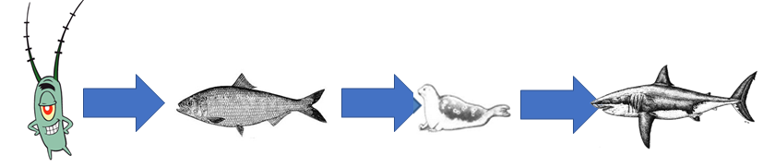
- One of the niches (job) of predator is to the prey population.
- If the top predator is , the population of that it used to eat will .
- The increased prey will put a on the that the prey uses.
Example of over hunting:
, ,
What does overhunting do with the do to an ecosystem?
- Another problem with over hunting is that a species is to extinction.
- refers to the elimination of an entire population of a
What’s the problem with extinction?
- When an organism becomes extinct, the species is gone .
- As ecosystem species to , that has less biodiversity.
- The less an ecosystem is, the less it becomes.
What is biodiversity?
- refers to the of that live is a given .
- When an ecosystem has a lot of species, if something happens to one population, another can take over the (job) of the lost (TO A POINT).

What would happen if a new organism is introduced into an ecosystem?
- Sometimes when a organism is into an existing , they can the food chain.
- If the new organism is better adapted for a niche, the original may be out competed. This new species is known an
- Also a new species can become a to a population that never have a predator before.
The Zebra Mussel
- The is a that was introduced to the ecosystem of the .
- Zebra mussels originally came from , but later reached , then the .
- They got here by to the bottom of .
- The problem with the is that it can quickly (spread) and the (original) shell fish. most of them.
Guam’s Brown Tree Snake
- is an in the Pacific Ocean.
- Until the mid 1900’s, the of Guam had no natural .
- from are thought to have been introduced to the island by in the gears of military airplanes.
- The Brown Tree snake is for more than half of the native population of the island.
Northern Snakehead Fish
- Originally from , the Northern was imported for use in .
- For some reason, they were in .
- These fish will eat in the water.
- They can also over land and invade stream or
- Introduce in , now all the way to
Pythons in Florida
- are at local pet stores for
- Pythons can get very (16 ft) very .
- Many Python let these snake into Florida because the owners cannot of them any more.
- Pythons are native to where their population is do to the presence of natural .
- With natural predators in the US, the snakes’ population explodes.
- With the of python in the swamp, animals are in .

