March Notes: Day 4 Evidence for Evolution
Name: Period: Date:
DO NOW: Underline the clue and fill in the missing word in these evolution sentences:
1) Organisms best adapted to a changed environment are more likely to , or mate, and pass off their genes to offspring
2) Evolution causes a population to develop new , or useful traits, over time. These new traits make the population more fit for its , or surroundings.
3) Present day life forms have from, or are descended from, earlier life forms.

What evidence is there that supports the theory of Evolution?
Evolution is a theory based on evidences that lead to speculated inference.
There are 5 main evidence that support evolution:
- The record
- Comparing (body structure)
- Developing
- Organs
- Comparing (mainly )
- The Fossil Record
A fossil is the remains or of an organism that has turned into .
Not all organisms turn into fossils. The need to be just right for to occur.
By fossils and them with other , scientists can piece together how organisms changed over time.

How do fossils support evolution?
The fossil record shows that species do not the over time.
Ex. Horse evolution- in of horse, of foot (from many toes to 1 toe)
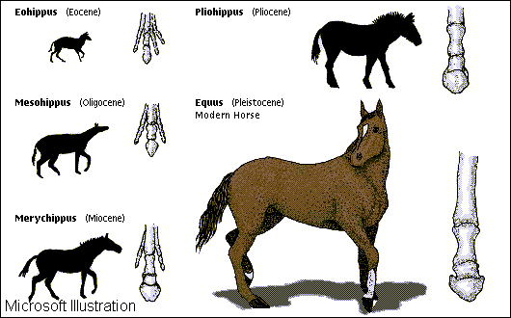
How do fossils support evolution?
In some cases, the record shows species that have of two very different kinds of . These organisms are known as species.
* species are because they show a link from one kind of organism to another.
- Comparing Anatomy
Similar structures- Many groups of organisms share (like bones), because they them from a .
Ex. The of humans, the of dogs and cats, the of birds, and the of whales all have the same types of bones (humerus, radius, and ulna).
The basic body plan of most are the same because the plan works well.
Because the plans work so , the are down from to .
The body plan may be due to a up of that were beneficial to that particular specie of .
These help change the of the organ thereby the of that organ.
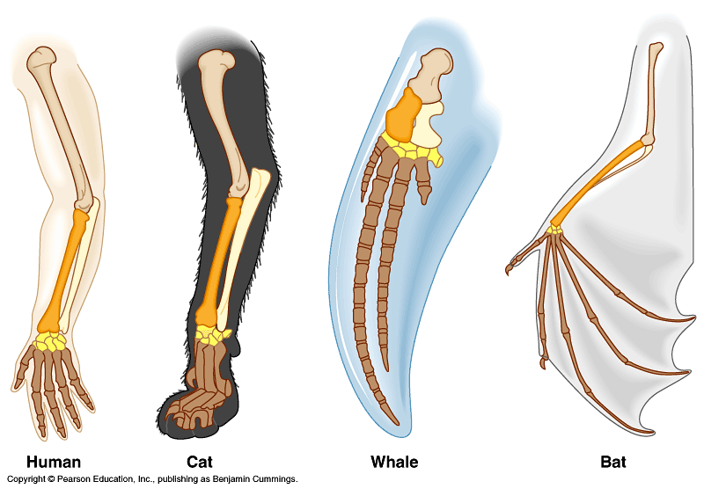
- Comparing Embryos
embryos of many animals, seem to each other.
As develop, turn on and off causing some to be the same and others not.
Because all came from one organism, all living things have parts of their in with other .
Because of having similar DNA, different organisms have similar genes.
The provide evidence that all experience stages during embryological .
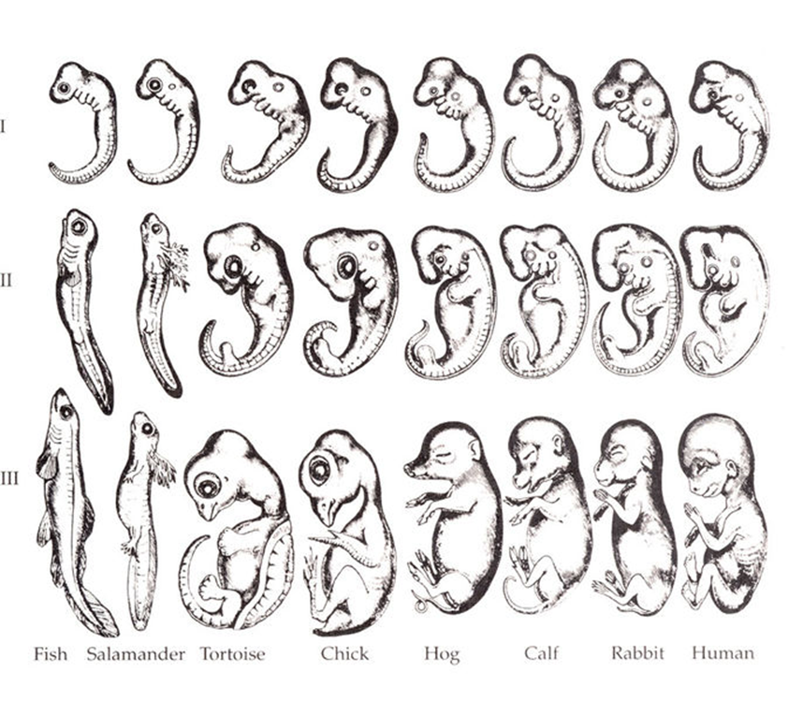
- Vestigial Organs
Organs are organs that have function to an individual but still .
It is believed that these organs are of organs that were once useful to our ancestor’s survival.
Examples are the human , wisdom , bone, male , the muscles used to wiggle the ears and the third eye lid.
- Comparing Biochemistry (molecular evidence)
Looking and comparing from different is the most accurate way to trace .
organisms have DNA.
The code (codon to chart) is the same for .All use the same code for the amino acids.
Using , if there are patterns, that means that those organisms have the same . The more genes they have in the more they are.
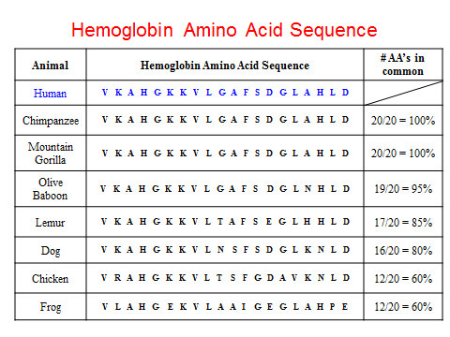
Protein similarities
If two have the same , that means they have the same . The more genes they have in the more they are.
Example: Human and gorilla are the same , therefore both have the same gene for hemoglobin.
Amino acid
Amino acid
Amino acid
Amino acid
Amino acid
PROTEIN

