**Tuesday, October 10, 2017 Name:**

**Aim: AIM: What is a cell and what are its parts?**

**DO NOW: Write down 5 things (concepts) that identifies if something is living or non-living.**

**1) What is life?**

In Biology, is defined not by what it , but by what it .

We call something that is alive an **.**

There are  t**hat** living things do that separate them from non-living things.

**2) What are the 8 life functions?**

- the ability to obtain and digest

-the ability to convert food (organic molecules) into .

-the ability to make that the organism cannot get from the environment.

-the ability to increase in

**-** the ability to move materials , out of and an organism.

**What are the 8 life functions? (cont.)**

the ability to remove made by cells.

**-** the ability to maintain

- -a stable internal environment in a changing external environment.

-the ability of an organism to more of its own kind

Not needed for the *individual* organism to survive, but needed for the *species* to survive.

**3) What is the smallest unit of life?**

Because the can perform all of the 8 , it is considered the smallest of life.

**4) Do you need cells in order to be alive?**

All organism, big or small, must contain at least one . Without these cells, we could not perform any of the 8

**When was the cell discovered?**

Until the invention of the microscope in 1590, no one ever seen or knew about cells. It was until 1663, when Robert Hooke looked at a thin slice of cork and coined the phrase “cell” which means small rooms.

**5) The Cell Theory**

Every is made up of or more .

The cell is the of and in all living things.

All cells come from (old) cells.

**6) Are there different groups of cells?**

Cells can be grouped into two categories:

- : these are cells that do

not have a .

Example:

- : these cells have a

distinct

**7) What are the types of Eukaryote cells?**

Eukaryotic cells fall into two categories:

a)

b)

**8) What are the parts of the cell that you can see under a microscope?**

The cell is made up of many different . Each part does a . The parts work together allowing the cell to survive. These parts are called .

**Organelles** are specialized parts of the cell that perform a specific job.

**Day 12** **AIM: The Cell -What you can see through a microscope?**

**How did the microscope change biology?**

Before the invention of the microscope, Scientists could not see and (unicellular organisms)

**The Light Microscope**

The earliest microscope was the .

It used light from the sun, candles and later the light bulb.

Light would move from the bottom of the microscope, though the (the thing you are looking at) and then through a series of

The light microscope magnified the specimen, making it appear

**What could you see with a light microscope?**

The best light microscopes can magnify a specimen up to its size.

A skilled scientist, using various and techniques, can see many inside a cell.  **Cell Membrane**

The :

FUNCTION:

* and the cell
* controls what goes (the bouncer)

STRUCTURE:

- is made of a layer

**Nucleus**

The :

FUNCTION:

* all of the activities of the cell (the control center)

STRUCTURE:

- enclosed by its own and contains the cell’s  **Cytoplasm**

The :

FUNCTION:

* is where the cell’s take place
* It’s the system of the cell

STRUCTURE:

- as a material consistently mainly of  **Cell Wall**

The

FUNCTION:

* Gives the cell and
* Does not interfere with the passage of materials into/out of the cell

STRUCTURE:

- Is made of

**What is an electron microscope?**

In 1928, two German scientists invented a microscope that can an image 2 millions times. This microscope was called an electron microscope.

Unlike a light microscope that use light to filter through a specimen. An electron microscope bombards the specimen with electrons.

**What can you see with the electron microscope?**

Because the electron microscopes can the specimen 1000 of times better than a light microscope with better resolution, we can see inside the cell with great

Organelles you can see with an Electron Microscope.

**Mitochondria**

are organelles the convert into

Mitochondria are found in the cytoplasm of the cell.

Cells that are very , like muscle cells, have lots of mitochondria because they need lots of

They are found in both and cells.

**Mitochondria**

**Ribosomes**

are small circles of membrane located in the cytoplasm on the endoplasmic reticulum (ER).

Ribosomes are the site where are bonded together to form chains.

**Endoplasmic Reticulum**

The Endoplasmic Reticulum (ER) is a series of channels or channels that help in the transport of large molecules, such as proteins, in and around the cell.

There are 2 types of ER

ER which has attach to it.

ER which has no ribosomes.

**Vacuole**

The vacuole is a in the cell.

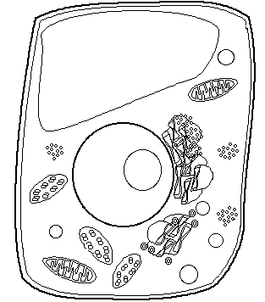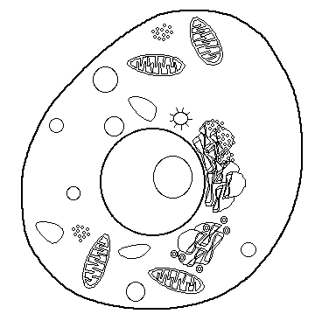

In plants the vacuole is and toward the c of the cell.

In animals, the vacuoles are small or mot there at all.

It holds extra or

It plants the vacuole helps give the plant support.

**Chloroplast**

Chloroplast are only found in .

This is the site of They change light energy into stored chemical energy (glucose).

They are found in the cytoplasm.

