February Notes: Day 7 Genetic Engineering
Name: Period: Date:
Aim: How can we change DNA to do what we want?
Do now: Write down a trait or a characteristic that you would want that exist in another organism.

Where do we get insulin from?
Insulin is an important produced by the . Insulin blood sugar.
People who suffer with cannot their own insulin.
Diabetics need to lots of insulin to survive.
So where do you think this insulin comes from?
Where do we get insulin from? → Special E.coli Bacteria human insulin.
HOW??? → Scientist insert a human into a bacteria’s DNA.
Why bacteria and not humans cells? → Bacteria and very and can product insulin . If you try to fix a pancreas cell, you would have to fix all hundred thousand of them which would be impossible.
What is Genetic Engineering?
Using a process called , we can DNA.
Genetic engineering is the of genetic material (a Gene) from one organism to another.
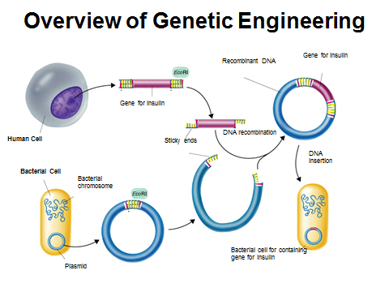
The example used is inserting the gene for insulin into a DNA.

Genetic Engineering in just 6 easy steps
- Find the for insulin in a human’s :
The insulin gene is located on 11.
- the insulin gene out of the human DNA using a
Restriction enzyme is an that cuts the DNA at a base sequence. REMEMBER: Enzymes are and proteins are specific.
- 3. Use the restriction enzyme to cut open the bacteria’s DNA ( ).
What do you notice about the bacteria’s DNA that is different? Bacteria DNA is not ladderlike
- Insert the human insulin gene into the plasmid and “glue it” using the same
- Put the plasmid (DNA) back into the and allow the bacteria to reproduce (mitosis).
- Since each bacterium has the human for , each one of the “new” bacteria insulin when its genes are expressed.
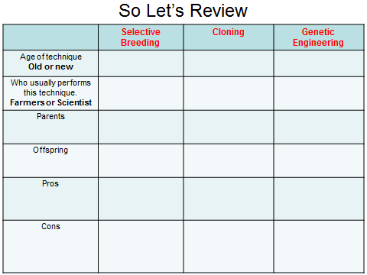
Pros and Cons Of genetic Engineering
Pros
Scientist can make “ ” organisms.
Scientist can make an organism any way they want.
Cons
Very to begin (lots of research).

