January Notes: Day 3 Mitosis and Meiosis
Name: Period: Date:
AIM: Reproduction at the Cellular level- Cell Division What is Mitosis? What is Meiosis?
Do now: Write down 2 ways something can grow

How do cells grow?
Cells can grow in two ways:
- Cells can grow by in , (getting )
- Cell can also grow by their , ( – Mitosis)
What is Mitosis?
- is a type of cell where a cell reproduces itself by to form two new cells ( ).
- Mitosis produces cells from an old one.
- This is how organisms and dead or cells.
What types of cells do mitosis?
- Single organisms use to . , and
- cells are any cell in the body and cells. cells, cells, cells and ect.
- Cells the is formed.
The steps of Mitosis (step 1)
- 1) The first step in is that cell must itself to
  - It must start all its . ( , , (plants))
  - In the ,the which is spread out in begin to (coil) to form . In humans there are 46 chromosomes.
  - The contains all the to the entire .
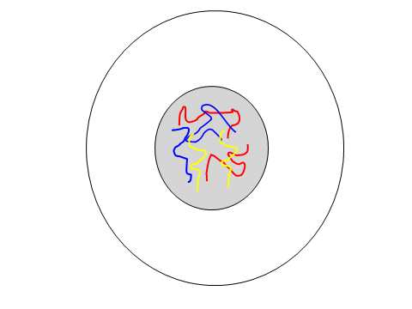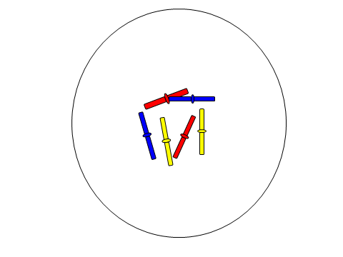
The steps of Mitosis (step 2)
- 2) The (DNA) begin to forming an “ ” like shape.
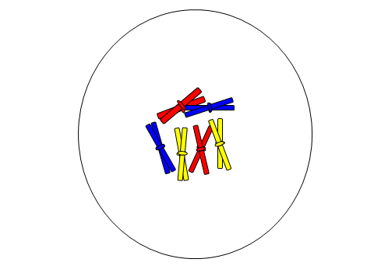

The steps of Mitosis (step 3)
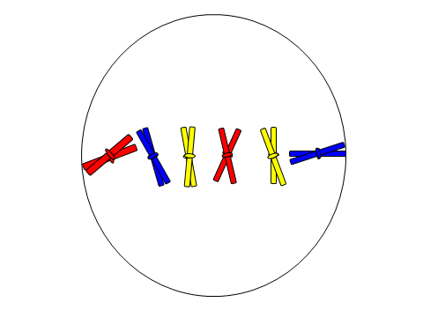
- 3) Now that the chromosomes are , they begin to up in the of the cell.

The steps of Mitosis (step 4)
- Small attached to the center of each begin to pull the “ ” shaped chromosomes apart and toward each of the cell.
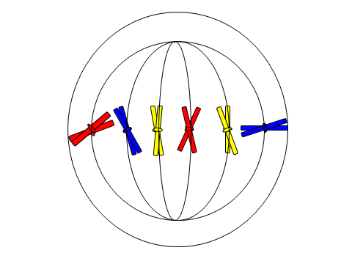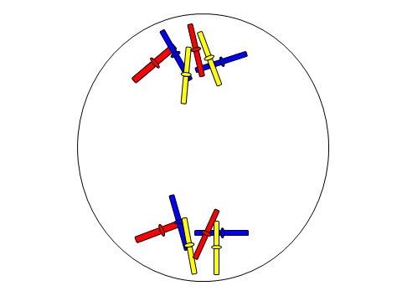
The steps of Mitosis (step 5)
- form around the newly and the cell begins to at the .
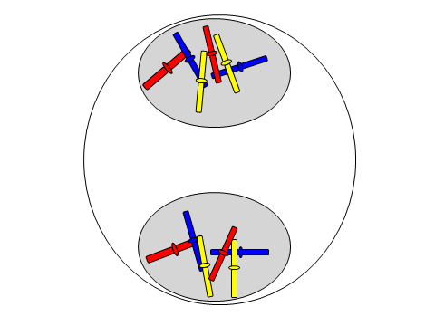
The steps of Mitosis (step 6)
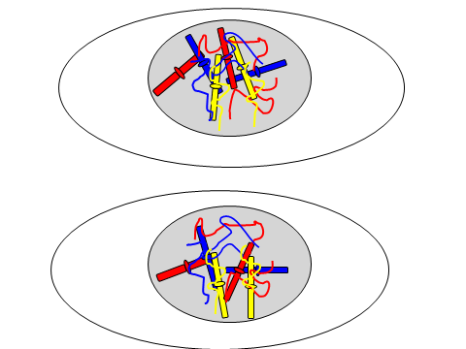
- Finally a membrane forms at the “ ” and are formed.
- The itself.

Mitosis and Asexual Reproduction
- In organisms, is a way to make more . Mitosis in
- In many (single cell) organisms, is the way they .
- Using mitosis as a means of reproducing is a form of ( parent) reproduction.
- Each is a and contains exactly the .
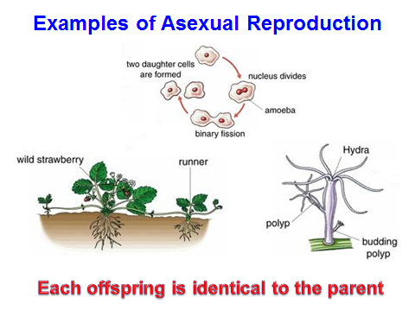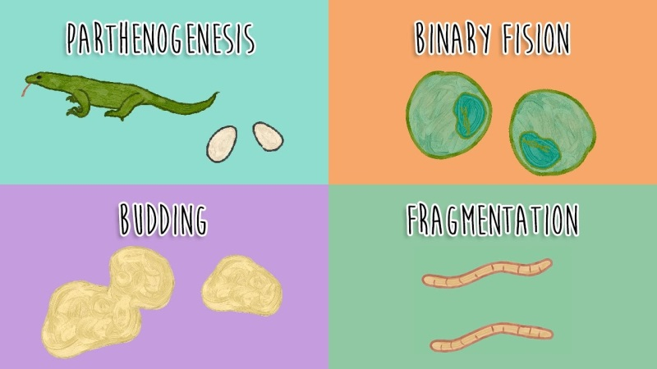
What is Meiosis?
- is another type of .
- of two cells in respect to the parent, the cell(s) will have the number of
- Meiosis occurs in the - and cells.
- Meiosis occurs in the sex ( in males, in females)
- Sex cells are called

Why do the daughter cells have half the chromosomes?
- The purpose of the sex cell in meiosis is to be able to with another sex cell to form a new cell “ ”.
- By having only the number of chromosomes, the of the two sex cells will result in a containing the of
( = whole)- one set of chromosome from the and one set from the .
- cells have chromosomes or therefore human gamete cell have____ non paired chromosomes.
- Because gametes are to make an , this form of reproduction is called reproduction.
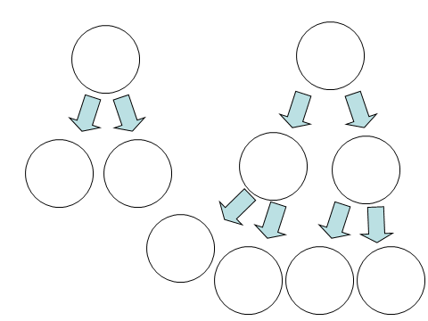
Steps of Meiosis
- The part of Meiosis follows the steps as in Mitosis, except instead of the DNA when the cells splits, the cell a time.
- This leaves the gamete cells a chromosome
Fertilization: The meeting of the Gametes
- A is a .
- Once the zygote is , the new will have some of the from the and some from the .
- This means that the contain some from the and some from the .
- For this reason, the developing will have (characteristics) of the mother and the father.
- How can I remember which cell division is which?
- use to make own cells
- My used to make .
Fertilization: The meeting of the Gametes (continued)
- Because creates cells with only chromosomes, when to (fertilization) the new cell (zygote) will have the number of ( pair or total).
- As a results of the gametes combining, the offspring will have ( features) from parents.
- In a human cell, the nucleus contains of chromosomes (a set of chromosomes from the and a set of chromosomes from the or a of chromosomes)
- Each of the 23 chromosomes are from each other and they are 1 through 23.
- When the chromosomes are (example: mother’s chromosome 5 & father’s chromosome 5), they are said to be (same)

