February Notes: Day Protein Synthesis
Name: Period: Date:
Aim: How is DNA used to make protein?
Do now: What is DNA? Where is DNA found? Why is DNA important?

From DNA to Protein
- DNA is a molecule
- It instructs a molecule called to make .
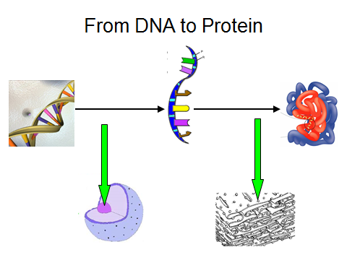
What is RNA?
- RNA ( ) is a molecule that the DNA to instruction to make proteins.
- Because DNA is a molecule, DNA cannot the is enough to leave the nucleus.

What are the difference between DNA and RNA?
DNA | RNA
It’s a stranded molecule | It’s a stranded molecule
It leave the | It leave the
Its bases are | It’s bases are
Base as follows: | Base as follows:

How to Make a Protein? Making a protein occurs in 2 steps:
- Transcription process where a RNA molecule is from a segment of molecule. Occurs in .
- Transcription process where RNA is used to synthesize from . Occurs in the .
Transcription
- A section of DNA “ ” at a gene.
- RNA begin to to one side of the unzipped DNA strand. Starting at one end and finishing at the other.
- Once the RNA is , it detaches from the and the .
- The DNA “ ” back up.
- of transcription
Translation
Translation begins the nucleus.
- The RNA goes to a .
- The ribosome the code letters at a time. These 3 letters are referred to as a
3) begin to based on the codons.
4) Amino Acids bind together forming a
A is a segment of DNA whose of bases contain the information to make a protein (which will result in a ).
Base pairing in RNA
pairs with U
pairs with G
Example:
- RNA G U A C
- DNA
A single DNA strand is shown below. Write the RNA strand that would be synthesized against the DNA strand above.
RNA→
DNA →G C C A T T A G G C A A T C C C
A single DNA strand is shown below. Write the RNA strand that would be synthesized against the DNA strand above.
RNA→
DNA →A T A T G C G C C A A T T G C G

