January Notes: Day 2 Fertilization to Birth
Name: Period: Date:
Aim: Human Reproductive System
Do Now: If every cell in your body has the same DNA, then why do we have different looking and functioning cells?

Don’t Copy
- During intercourse a male will ejaculate about 50 - 500 million sperm.
- These sperm will swim up through the female reproductive system.
- Not all of the sperm will reach the egg.
- Some sperm will reach the egg however only one will penetrate into the egg.
- The union of an egg and a sperm is called fertilization.
So what happens after fertilization?
- The process of combining a with an is called
- The majority of occurs in the
- Once the egg is fertilized ( ), it will have some from the and some DNA from the .
- The will continue to move down the till it reaches the .
- Once in the , the will itself into the .

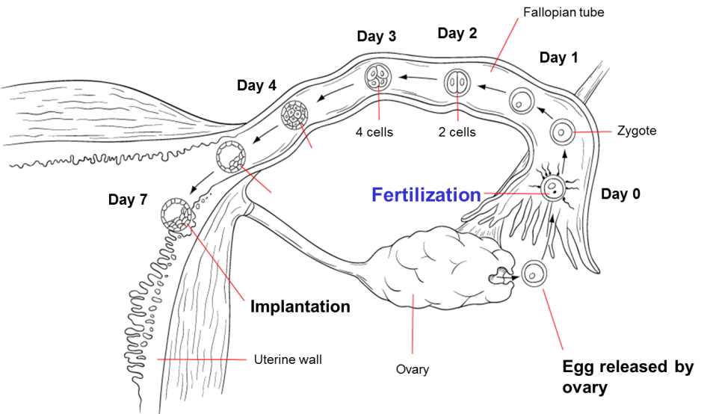
Day 0- The sperm the inside the , forming the
In 2 days- the into two . After this first division, the developing organism is now called an .
By day 4, the has divided to form a ball of 50 cells.
By day 5, the embryo is a of cells called a .
By day 7 (1 week), the becomes into the of the , where it continues to and .
How can one tiny cell make all the different cells in your body?
- the is the .
- The DNA contains all the to an .
- At first, all the in the are but as the zygote , the cells begin to move to a place.

How can one tiny cell make all the different cells in your body?
- Once the reaches its , certain genes “ ” and some “ ”
- This is called .
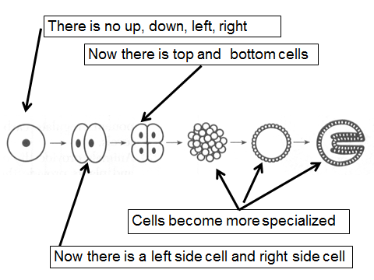
- are of on DNA that is for a specific job in the (example: eye color, height, skin color)
- The cells in the will eventually give rise to ALL different cells
- in the of the , all the cells are exactly the
- These cells are said to be or .
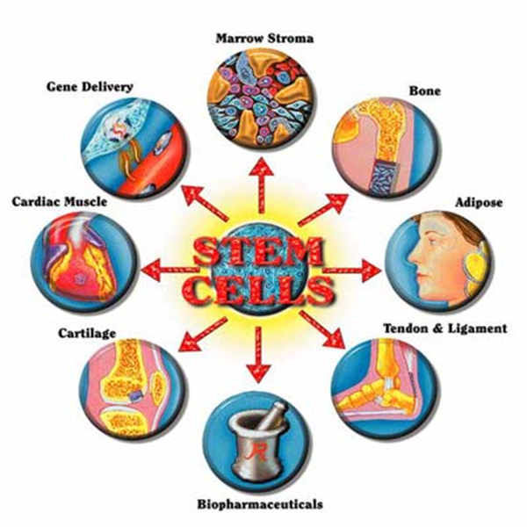
What are stem cells and why are they important?
- are the cells made during the first few cell divisions.
- Because these cells are not yet, they have the ability to become cell in the body.
- If a stem cell is and place in part of the body, the stem cell will grow into that part.
Problem with Stem Cells
- medical stem cells only come from .
- Removing these stem cells will the child.
- An problem occurs: Is it OK to “kill” a embryo to same someone else?
When is the embryo called a fetus?
- At weeks ( ), the developing organism is called a f .
- The fetus is suspended in a fluid-filled sac, called the .
- The fetus is totally by (it is “underwater”).
- This fluid protects the from and . (a pillow)
- The is a organ that the makes inside the uterus. It allows and to from the mother’s blood to the fetus’s letting the blood mix.
- Also, the placenta allows (like CO₂) to go from fetal to the mother’s where they can be .
- The placenta is to the fetus by the .
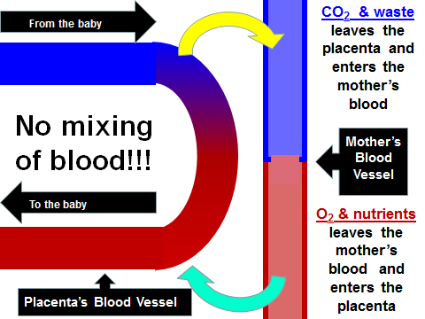
- Your is a left from your .
What goes in a mother, goes in the baby?
Substances like , and are molecules.
They can move through the .
These can the baby causing birth

