December Notes: Day 3 The Endocrine and Nervous Systems

Name: Period: Date:
Aim: How does the Body Communicate?
Do now: Describe how would you pass on a short message (Like to arrange a meeting time) to a friend across the city and how would you pass on a longer message (like a paper you’d like them to read for you) to that same friend.

What is your body made out of?
- Remember that our bodies are made out of a community of . Each type with their own that helps maintain
Discussion (Quiet write and be prepared to share)
- What are some of the reasons that cells might communicate with each other?
- How do you think cells communicate with one another? (For example, how do the cells in your brain communicate with the cells in your stomach?)
- Describe what might happen if communication between certain cells failed. (you many use a specific example)

What body systems does the body use to communicate?
The human body has 2 ways it sends messages:
- The System is used to send messages using impulses and .
- The System is used to send messages using and .
What are nerve signals?
- Our body’s nervous system is made up of billions of . These connect to form the and of the system.
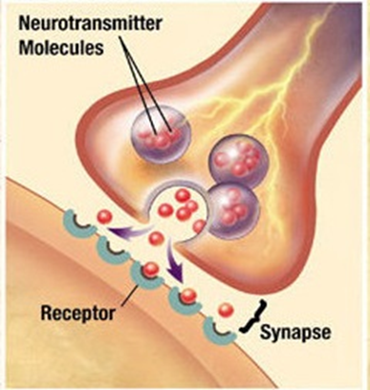
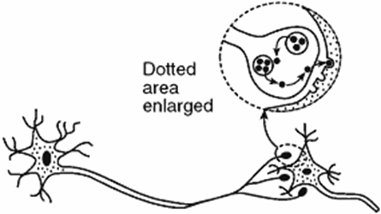
- passes throughout the which causes the release of a called which from the nerve to another cell.

What are synapses?
- are between 2 neurons or neurons and body cells. Neurotransmiters move from one cell to another to activate a function of that cell.
What are hormones?
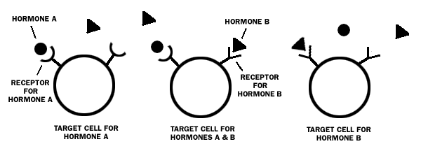
- Hormones are that travel throughout the body complex processes like , , and .

Where are hormones made?
- They are produced by called . These include the two glands, the gland, the four glands, the glands ( and ), the , the gland and the gland.
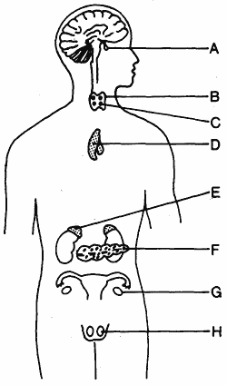

How do hormones work?
- and affect different and specific cells and cause specific actions to happen.
Example:
The secretes ( ) which “tells” cells that there is too in the blood and they have to take it in.
The pancreas also secretes which tells the cells in the liver that there is too in the and that they have to convert stored into
What is the difference between hormonal and nerve signaling?
- signaling sends , graded messages the body that are read by cells with specific receptors.
- signaling sends , digitized messages over connections.
- Neural communication is more than hormonal communication.
Exit slip
- What is the name of the cells that makes up the nervous system?
- What is the name of the type of organs that make hormones?
- What type or organic molecules are neurotransmitters and hormones? (they are the same)
- What are 2 differences between the signals of the nervous system and the endocrine system?

