December Notes: Day 1 The Urinary System

Name: Period: Date:
Aim: What is the function of the urinary system?
Do Now: Why is feces not considered cellular waste?

What is the difference between urine and feces?
- is what is over from when we .
- is the way our bodies get rid of .
- Metabolic waste is made by all the in our body such as , (waste made by breaking down ).
What is urinary system?
- The system that includes all organs involved in making and excreting (eliminating) of urine.
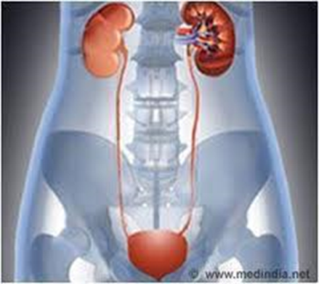
It includes:
  - : -shaped organs about the size of your fists near the middle of the back
  - : thin tubes that move urine to the
  - : organ shaped like a
  - : tube that allows urine to pass the body

How is urine made?
- The made by the is back into the .
- The carries the waste to the
- Like the , the have a lot of blood going through it.
- surround small structures is the kidneys called . These collect the waste and collected mix it with
- The resulting mix is .
Adjustment of the water content
- Water is taken into the body as food and drink and is lost in three ways

Do we sweat pee?
- The waste that excreted in is the same that is excreted in . This is the reason both sweat and urine are . And the reason your white shirts sometimes get under arms.
Do Not Copy
- Sometimes the concentration of urine is so great that minerals in the urine bind together forming small stones.
- If the stones are small enough, they can pass through the urinary tract.
- If the stones are large, they made need to be surgically removed.
- The largest kidney stone was 2.5 lb and the size of a coconut.
Do you pee more in the summer or winter?
- On you pee . This is because you . This urine is in color and
- On you This is because you using up more water. This urine and in color .
Lets make sure we got this
- What is urine?
- What 4 organs make up the urinary system?
- When would you pee more, winter or summer?
- Why?

