March Notes: Day 5 Phylogenetic Tree
Name: Period: Date:
Aim: Does Evolution Happen Today?
Evolution - Review
- Evolution is a in a of organisms over a period of
- Within every , there are who are slightly .
- These are the results of in the .
- These lead to new that can or an individual to .
- “Survival of the ” and “ selection” means that who have better will survive and on these traits to their
- If the does not , then those become .
- An individual’s can also help with natural . If the behavior helps the individual to , the behavior may be pass on to (instinct or teaching).
Evidence for Evolution - Review
- Although evolution is only a theory, there are lots of that support it.
  - show a in species
  - show body that are shared by animals
  - development seem to be similar in many animals.
  - Similar are found in different animals using the same
  - Similar are found in different organisms.

Reading Phylogenic Trees
- shows how change over time.
- The oldest part of the tree is always where there is only one line.
- As the line , time become closer to our time.
- A species occurs at the point where the line split.
- Sometime the make it to the , which means that the still today.
- Sometime the line before it reaches the . This means that the organism became .
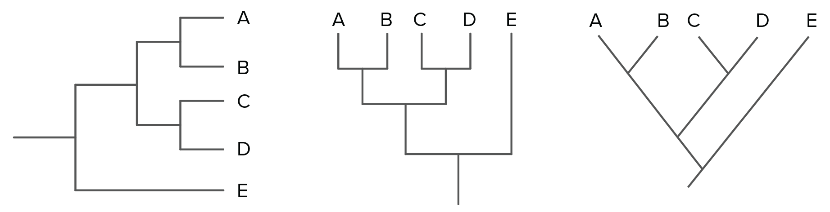
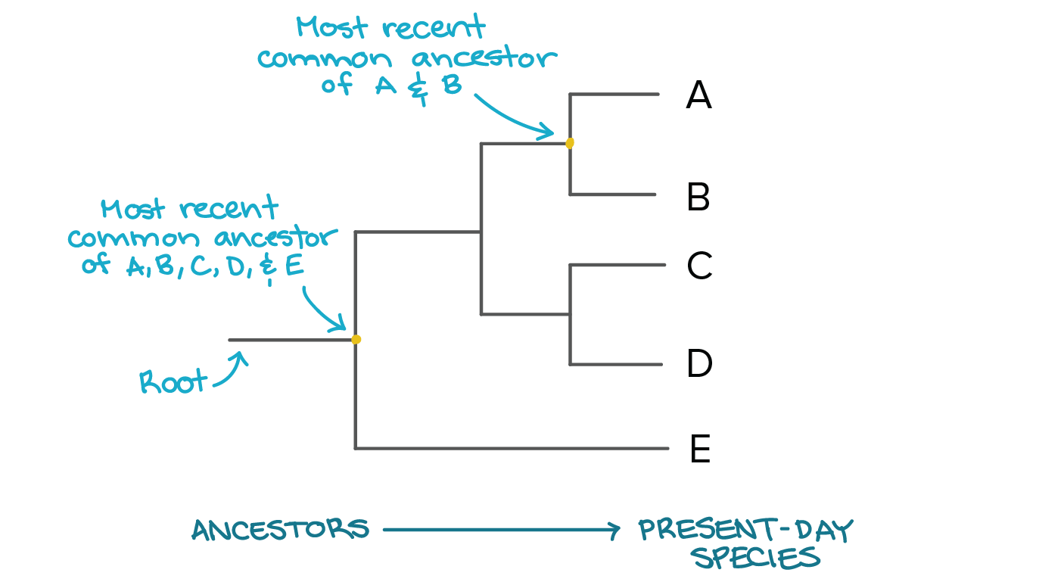
Antibiotic Resistant Bacteria
- Doctors use antibiotic ( ) to kill that occur in the body.
- The is designed to kill . But because within every , there are individuals who are different; some bacteria may have a mutation that makes them resistant the antibiotics.
- The all the bacteria except for these mutated bacteria.
- These reproduce and pass on their genes to their offspring.
- Now all the new are resistant to the medicine and the medicine does not work.
- antibiotics are needed to kill the new bacteria.
Pesticide Resistant Insects.
- use to kill insects that eat their crops.
- The are designed to kill insects. But because within every , there are who are slightly ; some insects may have a mutation that makes them to the pesticide.
- The pesticide kills all the insects except for these insects.
- These insects and pass on their mutated genes to their offspring.
- Now all the insects are to the and the pesticide does not
- New are to kill the new .
The Key to a Species Chances to Survive
- The is always . (climate, amount of resources)
- that have the most will have a chance of some surviving sudden changes. These individuals will reproduce and keep the species from becoming extinct.
- Populations that have few or will die out if the environment changes too .
What is the best way to reproduce?
- reproduction is .
  - Only parent is needed.
  - variation (clones)
  - If a mutation occurs, the mutation will quickly move through the population.
- reproduction is .
  - Needs individuals
  - of variations (Chromosome )
  - move slow through a . (mutation has to occur in the or cells in order to be passed on to ).

