HW #9

High School for Public Service
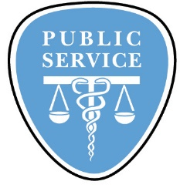
Ms. Reid’s Weekly Living Environment Homework Packet
Due before class starts on Wednesday, December 6th, 2017.

Name: _____________________________________________________
Period: ________
Cool Science Fact of the Week!

1) It's impossible to sneeze with your eyes open

2) Your stomach needs to produce a new layer of mucus every two weeks or it would digest itself.

3) Children grow faster in the springtime.

4) It takes the stomach an hour to break down cow milk.

5) When you sneeze, all your bodily functions stop even your heart.

6) The average surface of the human intestine is 656 square feet (200 m).

7) Chewing gum while peeling onions will keep you from crying.

8) If you are right handed, you will tend to chew your food on your right side. If you are left handed, you will tend to chew your food on your left side
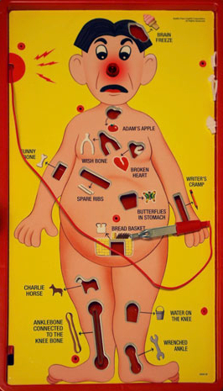

Bodies Museum Field Trip

Name ________________________________ Date______________

Important Reminders:

You have a quiz December 6th

Topics for the week:

The Respiratory System, Circulatory System

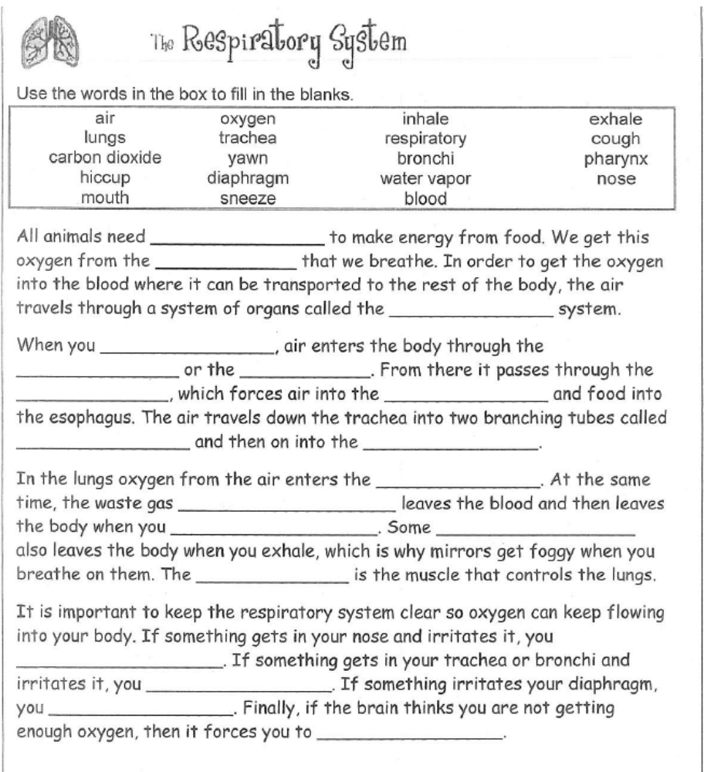

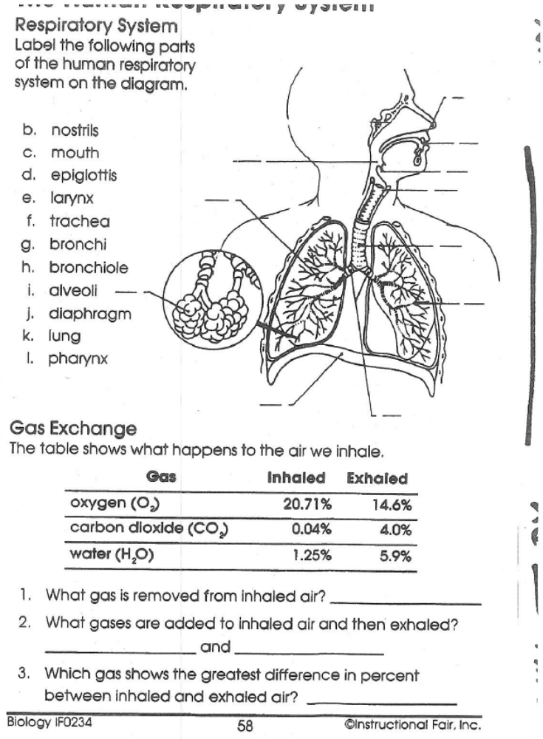

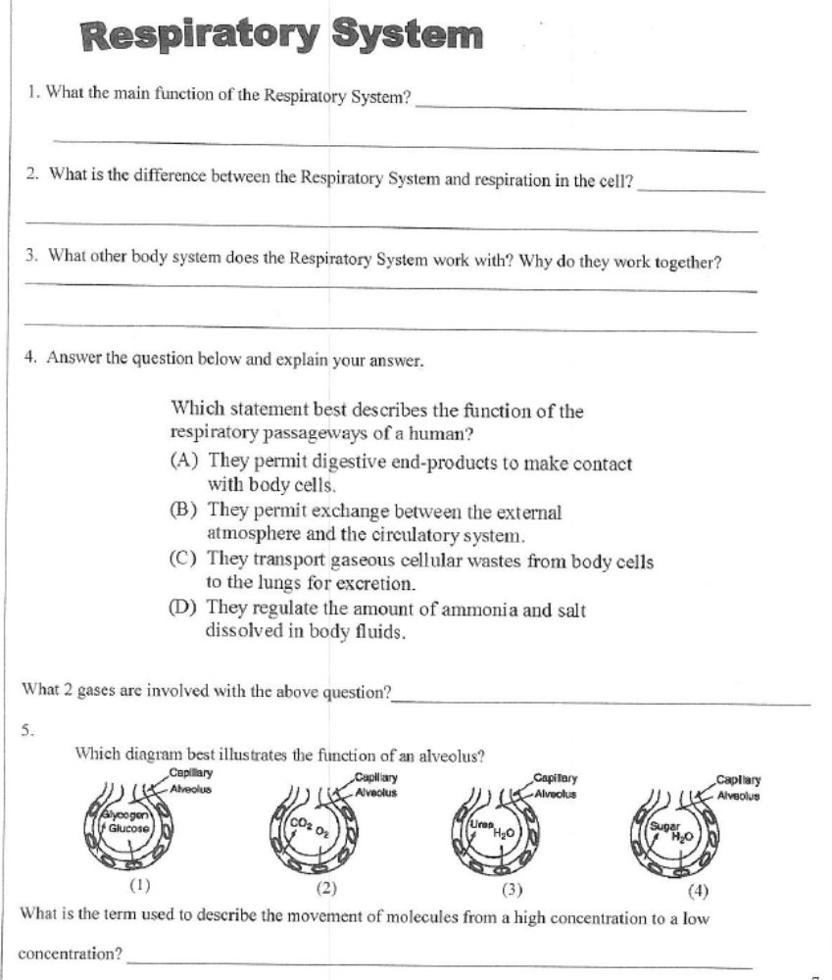

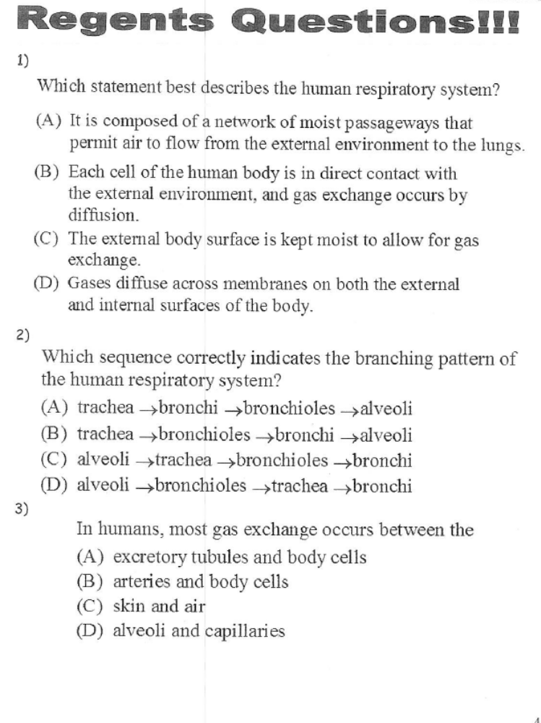

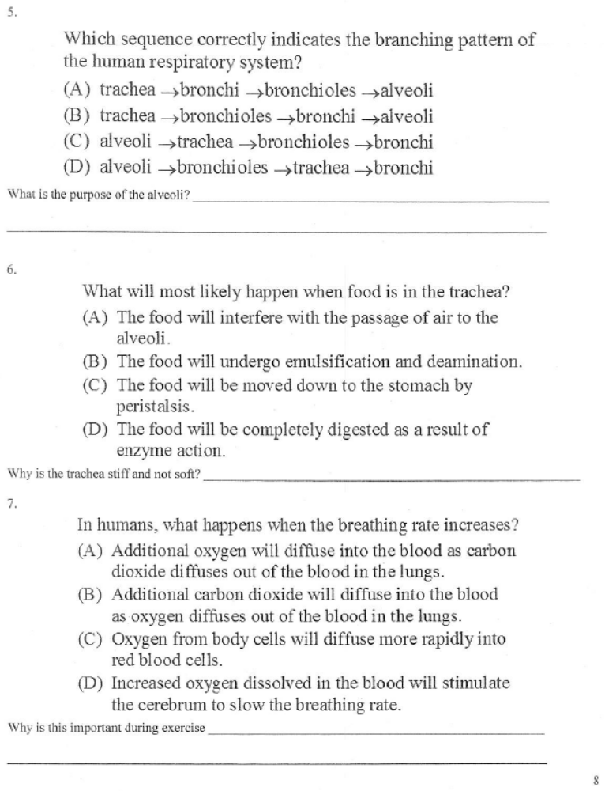

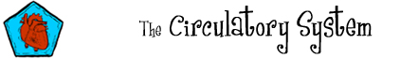

Use the words in the box to fill in the blanks.
veins  arteries  nutrients  capillaries  away | transport  oxygen  energy  dark  heat | circulatory  lungs  carbon dioxide  bright  to | blood  heart  pumped  intestine  atmosphere
All animals need to ________________ materials around to the different parts of their body. This is the job of the ________________ system. The circulatory system consists of a liquid called _______________, a pump called the ________________ and a series of vessels called _________________ and ________________.

One thing that must be transported around is a gas called _____________. Oxygen enters the blood through the ______________. It is then ____________ through the heart and around the body where it is used along with food to make ______________. The body produces another gas called _______________, which is a waste product. This gas is carried back to the heart and then to the lungs where it is released back into the _______________.

The vessels that transport blood _________ from the heart are called arteries. The blood in arteries is _____________ red because it is rich in oxygen. The vessels that transport blood _______________ the heart are called veins. The blood in veins is ______________ red because it is low in oxygen. ________________ are small vessels that join the arteries and veins.

_______________ from food are also transported around the body by the circulatory system. They enter the blood from the small _________________. The circulatory system also helps to regulate temperature by transporting _________________ around the body.

The Heart

The heart is a muscular organ that pumps blood through the circulatory system. The heart is two pumps in one.
The function of the right side of the heart is to collect de-oxygenated blood, in the right atrium, from the body and pump it, into the right ventricle which then pumps it to the lungs. Once at the lungs, the de-oxygenated blood drops off the carbon dioxide and picks up oxygen. This exchange of gases is done by diffusion. Because there are different concentrations of gases in the blood and in the lung, these gases will move from an area of high concentration to an area of low concentration without the use of energy. The now oxygenated blood returns to the heart. This movement of blood from the heart to the lungs and back to the heart is known as pulmonary circulation.
The left side of the heart collects the oxygenated blood in the left atrium. The left atrium moves the blood into the left ventricle which than pumps the blood into the body's largest artery called the Aorta. The aorta then distributes the blood to the rest of the body. This movement of pumping blood the whole body is known as systemic circulation.
The heart is divided into two side by a structure called the septum. The septum do not allow the blood from the right side of the heart to mix with the left side. This would be bad because blood with no oxygen will mix with blood going to the body.
On both side of the heart, the lower ventricles are thicker and stronger than the upper atria. The muscle wall that surrounds the left ventricle is much thicker than that of the wall surrounding the right ventricle. This is due to the fact that the left side of the heart needs to pump at a higher force to get the blood to the whole body.

Read the passage on page 3 and answer the following questions.

1) What is de-oxygenated blood? _________________________________
2) Where did de-oxygenated blood come from? _______________________
3) Where does de-oxygenated blood enter the heart? __________________
4) Where does de-oxygenated blood go after it leaves the heart? _________
5) What is oxygenated blood? ____________________________________
6) Where did oxygenated blood come from? _________________________
7) Where does oxygenated blood enter the heart? _____________________
8) Where does oxygenated blood go after it leaves the heart? ____________
9) Why is the septum important? _________________________________
10) Why is the left ventricle more muscular than the right ventricle? _______
__________________________________________________________
11) What is pulmonary circulation? _________________________________
12) What is systemic circulation? _________________________________

What is a Heart Attack?

A heart attack (also called “myocardial infarction”) occurs when a blood vessel supplying blood to a part of the heart becomes blocked, resulting in permanent damage to the heart muscle due to the lack of blood flow. This blockage of blood doesn't allow oxygen and nutrients to get to areas on the other side of the blockage. The blood vessel can become blocked from advancing atherosclerotic plaque lesions, a sudden formation of a blood clot, or a buildup of fat deposits in the coronary artery - an artery that supplies blood to the heart.
Most people believe that a heart attack is caused by a slow, progressive build-up of plaque, comforting themselves that it takes a lifetime to become completely clogged - but this just isn't true for a majority of heart attacks. Heart specialists now believe that most heart attacks occur when an unstable, atherosclerotic plaque lesion, filled with cholesterol and fat, suddenly breaks apart, thus forming an open wound within the artery wall. Blood platelets and clotting proteins rush to the wound and form a clot — called a thrombus. The clot can enlarge in a matter of moments, causing obstruction (restriction) of blood flow to the heart causing angina (chest pain). If the blood flow becomes completely obstructed (blocked), a heart attack ensues (occurs).
Surprisingly, it is the small plaques that can be the most lethal. A person with a 50% blockage who suddenly becomes obstructed is at much greater risk of having a large amount of heart damage than a person with a slowly progressive blockage. A person with a 90% blockage that was slow to progress has probably had a chance to develop “collaterals”–– smaller blood vessels that grows around the blockage, to take over the job of the big vessel that has been gradually closing down.

Read the passage on page 5 and answer the following questions.

1) What is another name for a heart attack? ________________________
2) What causes a heart attack? __________________________________
3) Why is a blockage in a blood vessel in the heart bad? _________________
___________________________________________________________
4) Where does the fats and the cholesterol come from? (not in passage) _____
___________________________________________________________
5) What is a thrombus? _________________________________________
6) Why is it better for a person to have slowly progressive blockage than a sudden blockage? _____________________________________________
7) What artery supplies the heart with oxygen and nutrients? _____________
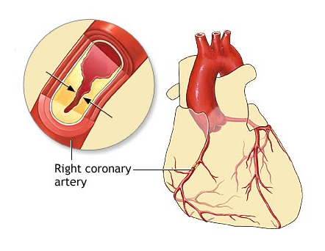

1)
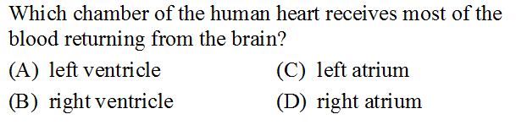
2)
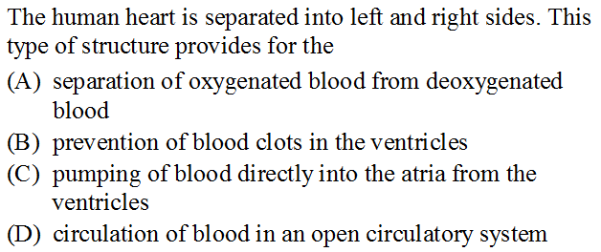
3)
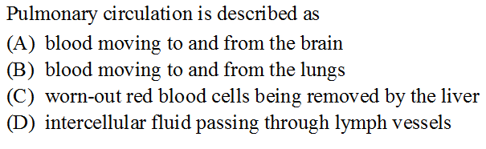

4)
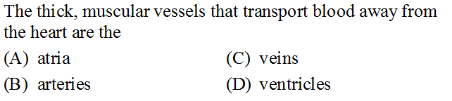
5)
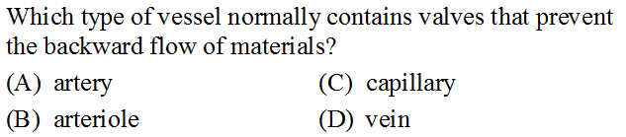

6)
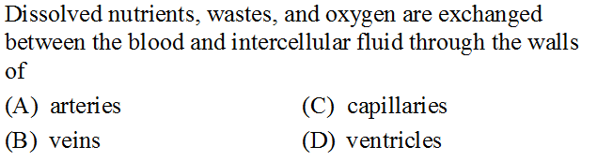

7)
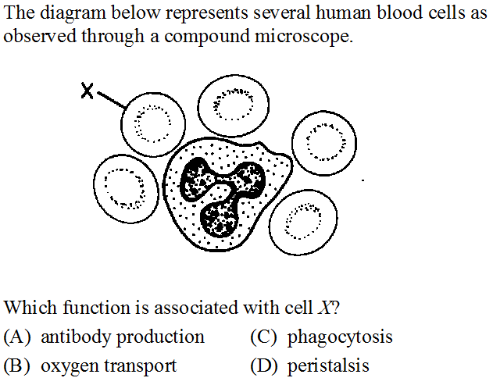

8)
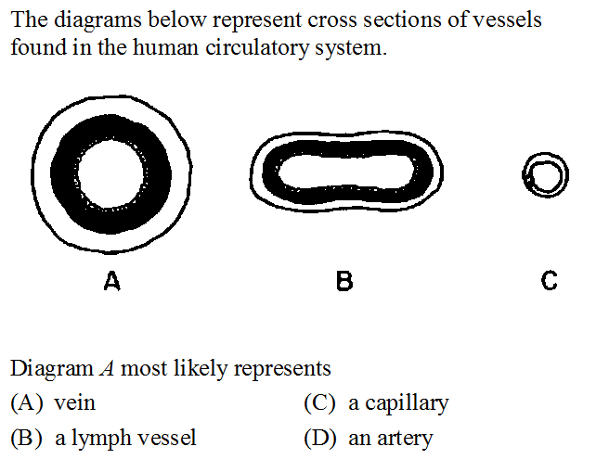

9)
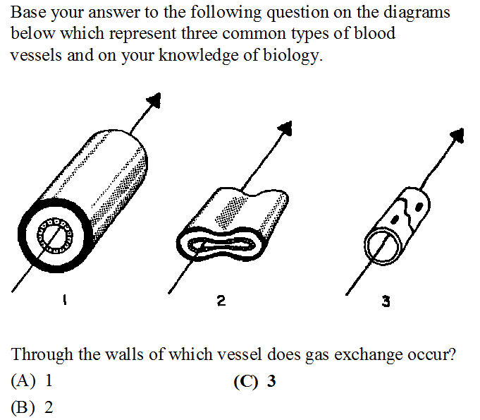
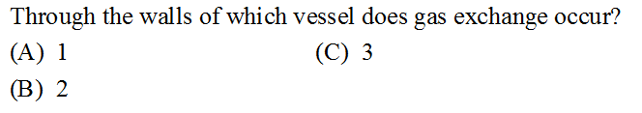

10)

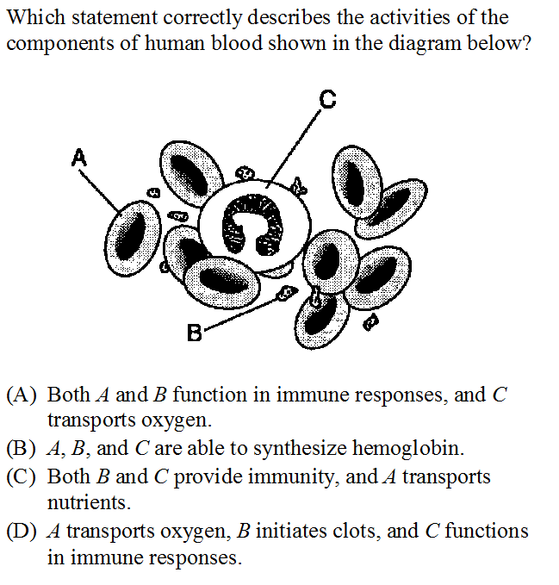
11)


