**High School for Public Service**

**HW #1**

**Ms.  Reid’s Weekly Living Environment**

**Homework Packet**

**Due before class starts on Wednesday, September 13, 2017.**

Name: \_\_\_\_\_\_\_\_\_\_\_\_\_\_\_\_\_\_\_\_\_\_\_\_\_\_\_\_\_\_\_\_\_\_\_\_\_\_\_\_\_\_\_\_\_\_\_\_\_\_\_\_\_

Period: \_\_\_\_\_\_\_\_

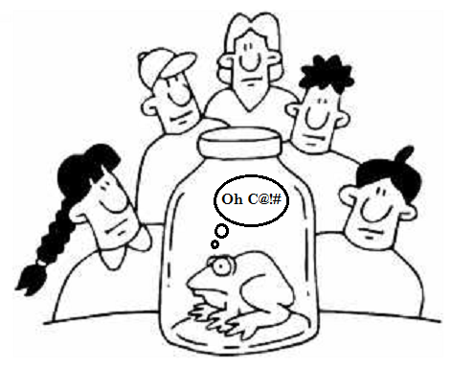

**Cool Bio Facts of the Week!**

1. [Dolphins grey_loader](http://scienceray.com/biology/zoology/13-amazing-facts-about-animals-world/" \t "_top)

sleep with one eye open

2. Crocodiles are color-blind

3. Owls are the only bird that can see the color blue  
4. Unlike all other insects, flies have five eyes. They have two large eyes and three smaller eyes between them.

5. Snails have four noses.  
  
  
Read more: <http://scienceray.com/biology/zoology/13-amazing-facts-about-animals-world/#ixzz0xq8m4x2A>

Read more: <http://scienceray.com/biology/zoology/13-amazing-facts-about-animals-world/#ixzz0xq8TEiwG>

**Important Reminders:**

* You must hand in your signed SYLLABUS BY Friday
* You need a notebook and folder or a section in a 3 ring binder with loose leaf , a pen and a pencil

**Topics for the week**:

Scientific Method

Name \_\_\_\_\_\_\_\_\_\_\_\_\_\_\_\_\_\_\_\_\_\_\_\_\_\_\_\_\_\_\_\_ Date\_\_\_\_\_\_\_\_\_

**Scientific Method Identification**

***Directions:*** Read each numbered statement below

**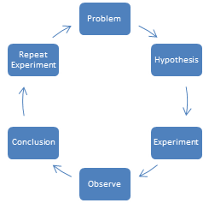**(a) Decide whether the statement is a problem or a hypothesis. Circle your answer.

(b) Identify the independent

(c) Identify dependent variable



**Example: How does sunlight affect plant growth?**

1. Problem or Hypothesis
2. Independent variable: Sunlight
3. Dependent variable: Plant growth
4. **The activity of enzymes will decrease with an increase in temperature.**
5. Problem or Hypothesis
6. Independent variable: \_\_\_\_\_\_\_\_\_\_\_\_\_\_\_\_\_\_\_
7. Dependent variable: \_\_\_\_\_\_\_\_\_\_\_\_\_\_\_\_\_\_\_\_
8. **The respiration rate of a fish will increase with an increase in temperature.**
9. Problem or Hypothesis
10. Independent variable: \_\_\_\_\_\_\_\_\_\_\_\_\_\_\_\_\_\_\_
11. Dependent variable: \_\_\_\_\_\_\_\_\_\_\_\_\_\_\_\_\_\_\_\_
12. **Does the presence of pollutants affect the number of mutations in a frog?**
13. Problem or Hypothesis
14. Independent variable: \_\_\_\_\_\_\_\_\_\_\_\_\_\_\_\_\_\_\_
15. 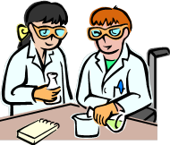Dependent variable: \_\_\_\_\_\_\_\_\_\_\_\_\_\_\_\_\_\_\_\_
16. **How does the amount of homework affect a student’s overall grade?**
17. Problem or Hypothesis
18. Independent variable: \_\_\_\_\_\_\_\_\_\_\_\_\_\_\_\_\_\_\_
19. Dependent variable: \_\_\_\_\_\_\_\_\_\_\_\_\_\_\_\_\_\_\_\_
20. **Insulin lowers blood sugar best at 37o C.**

(a) Problem or Hypothesis

(b) Independent variable: \_\_\_\_\_\_\_\_\_\_\_\_\_\_\_\_\_\_\_\_

(c) Dependent variable: \_\_\_\_\_\_\_\_\_\_\_\_\_\_\_\_\_\_\_\_\_\_

**A Tale Told by Tracks**

In a park on a chilly winter day, you see mysterious animal tracks in the snow, as shown in the illustration below. The illustration has been divided into three sections. Look at these tracks carefully, and use your observations to make inferences about the animals.

**Section 3**

**Section 2**

**Section 1**



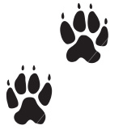













































1. In the data table below, write an observation of the tracks in each of the three sections of the illustration. Then write any inferences that you can make about the tracks in each section.

|  |  |  |
| --- | --- | --- |
| **Data Table** | | |
| **Section** | **Observations** | **Inferences** |
| **1** |  |  |
| **2** |  |  |
| **3** |  |  |

1. How many types of animals made the tracks shown in the illustration? What observation section gives you the answer?
2. What inferences, if any, can you make about the relative size of the animals?
3. What do you think happened in section 2?
4. What inference can you make base on the tracks in Section 3?

**FORMING A HYPOTHESIS**

**REMEMBER!!!!!!**

**A hypothesis is a statement. It is not a question (the problem). You may use the words, “I believe or I think” to begin the sentence. Of, use the word, “if and then.”**

**For example you could write: If the activity level increases, then the heart rate will also increase.”**

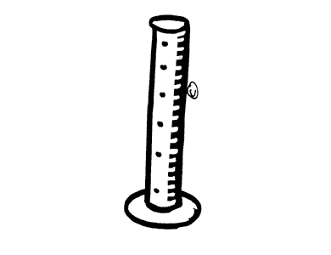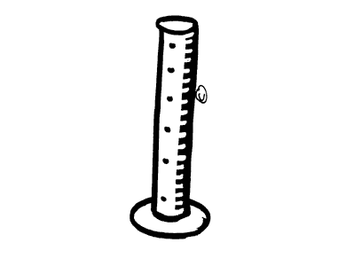 

**Example 1**

Three graduated cylinders of equal size and shape are on a leveled lab table. Each graduated cylinder is filled to the top with a liquid. Cylinder (a) contains water, cylinder (b) contains vegetable oil, and cylinder (c) contains maple syrup. The teacher instruct a student to drop a metal ball into each cylinder at the same time have another student record the time it took the metal ball to reach the bottom of the cylinder.

**1) State the problem** \_\_\_\_\_\_\_\_\_\_\_\_\_\_\_\_\_\_\_\_\_\_\_\_\_\_\_\_\_\_\_\_\_\_\_\_\_\_\_\_\_\_\_\_\_\_\_\_\_\_\_\_\_\_\_\_\_\_\_\_

**2) Write a possible hypothesis** \_\_\_\_\_\_\_\_\_\_\_\_\_\_\_\_\_\_\_\_\_\_\_\_\_\_\_\_\_\_\_\_\_\_\_\_\_\_\_\_\_\_\_\_\_\_\_\_\_\_\_\_

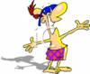

**Example 2**

A student wants to know if time has any effect on the effectiveness of sun block lotion. The student finds three bottles of sun tan lotion. All three bottles are made from the same company and contains the same SPF (Sun Protection Factor). The first bottle (a) is a brand new bottle the student just bought today, the second bottle (b)was bought last summer ( about one year ago), and the third bottle (c) was bought approximately two years ago.

**1) State the problem** \_\_\_\_\_\_\_\_\_\_\_\_\_\_\_\_\_\_\_\_\_\_\_\_\_\_\_\_\_\_\_\_\_\_\_\_\_\_\_\_\_\_\_\_\_\_\_\_\_\_\_\_\_\_\_\_\_\_\_\_

**2) Write a possible hypothesis** \_\_\_\_\_\_\_\_\_\_\_\_\_\_\_\_\_\_\_\_\_\_\_\_\_\_\_\_\_\_\_\_\_\_\_\_\_\_\_\_\_\_\_\_\_\_\_\_\_\_\_\_

**Example 3**

Light, when passed through a prism, separates into different wavelengths. These wavelengths will shows up as different colors; ranging from purple to red. A student is interested in finding out the ideal wavelength (color) of light a particular green plant grows best in.

The student takes fie separately potted plants (all the same species), and places them in five large boxes that will not allow outside light to enter. The first box will have a lamp with a purple bulb in it. The second box will have a yellow bulb, the third box will have a green bulb, the forth will have a red bulb and the fifth box (the control plant) will have a regular white bulb.

All the plants will receive the same duration of light, the same amount of water and food. Water and food will be administered at night to minimize any contamination from outside light.

After four weeks, the plants are taken out to study.

**1) State the problem** \_\_\_\_\_\_\_\_\_\_\_\_\_\_\_\_\_\_\_\_\_\_\_\_\_\_\_\_\_\_\_\_\_\_\_\_\_\_\_\_\_\_\_\_\_\_\_\_\_\_\_\_\_\_\_\_\_\_\_\_

**2) Write a possible hypothesis** \_\_\_\_\_\_\_\_\_\_\_\_\_\_\_\_\_\_\_\_\_\_\_\_\_\_\_\_\_\_\_\_\_\_\_\_\_\_\_\_\_\_\_\_\_\_\_\_\_\_\_\_

**Practice Regents Questions**

1) Base your answer to question on the information and diagram below and on your knowledge of biology.

The presence of air is believed to be important for root growth in bean plants. The apparatus available to conduct an investigation is shown below. There are enough bottles and other materials to have multiple setups. Air (for aeration) can be bubbled into the bottle through the rubber tube.

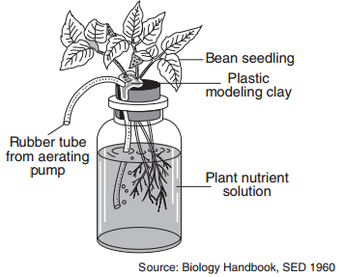

Design an experiment to test the effect of aeration on the growth of roots of bean seedlings. In your answer, be sure to:

• State one hypothesis the experiment would test [1]

• Describe how the control group will be treated differently from the experimental group [1]

• Identify the dependent variable in the experiment [1]

• State one reason why many setups should be used in both the experimental and control groups [1]

• State one reason why several different kinds of seedlings were not tested in this experiment [1]

2) Many plants can affect the growth of other plants near them. This can occur when one plant produces a chemical that affects another plant.

Design an experiment to determine if a solution containing ground-up goldenrod plants has an effect on the growth of radish seedlings. In your experimental design be sure to:

• State a hypothesis to be tested

• Describe how the experimental group will be treated differently from the control group

• Explain why the number of seedlings used for the experiment should be large

• Identify the type of data that will be collected

• Describe experimental results that would support your hypothesis