Monday, October 23, 2017 Name:
Day 13 AIM: What is diffusion and what does it have to do with concentration?
DO NOW: Explain why putting an air freshener in the corner of a room will make the entire room smell good.

What is diffusion?
- is the movement of molecules from an area of concentration to an area of concentration.
- An arrow is used to show the of diffusion
high conc. Low conc.
What is meant by Concentration?
- refers to the ratio of to in a solution.
- = material being dissolved
- =material doing the dissolving
- = resulting mixture
Why does diffusion occur?
- Diffusion occurs because are always .
- Because they are moving they tend to into each other.
- This bumping causes them to move from each other over .
- Over time these molecules become distributed
Why does diffusion occur? (cont)
- Because molecules are and in to each other and moving from each other, it is said that molecules move from areas of to areas of .
- This stops when the molecules reaches an .
So what does diffusion and concentration have to do with Biology?
- Diffusion is a occurring process.
- Molecule move and of cell through this process because the cells need to perform the 8 .
- Some things that move into the cell are …..

  - Nutrients (sub units: , , & )
- Some things that move out of a cell are …..
  - Cellular ( and )
  - Cell ( )
The Cell Membrane (the bouncer)
- Not every can enter or leave the cell by .
- These molecules are by the cell membrane.
- The cell’s membrane acts like a net, those molecules that are small can easily through the holes of the membrane, while large molecule are too to fit through the hole and stay behind.
What can go through the membrane and what can’t?

What can

What Can’t

What is the pattern between those things that can and those that can’t go through the membrane?

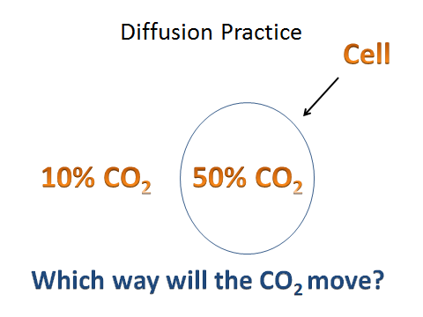
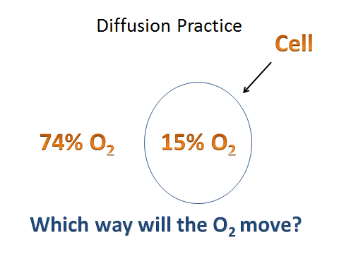

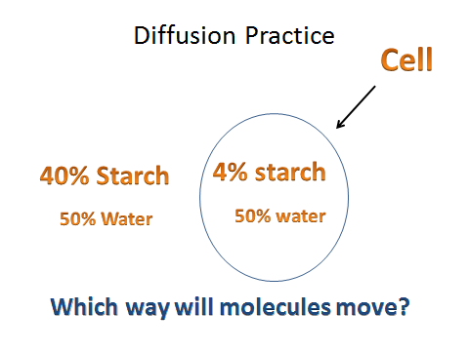
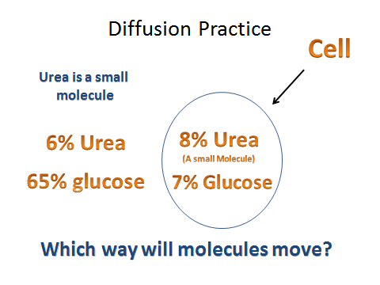

Day 14
DO NOW: What happens when you put salt on a slug or a snail?
AIM: What is Osmosis?
What is osmosis?
- is the of through a .
- Like regular diffusion, water will move from one concentration to another until both sides in concentration
How is osmosis different than diffusion?
- In diffusion, the (the dissolved material) moves from a high concentration to a low concentration.
- Remember that the solute is molecules such as , , , , and .
- But because some molecules are too to get across the membrane, has to move in toward these large molecules in order to dilute the concentration.
What are the effects of osmosis? (a)
- If the concentration of inside the cell and outside the cell is the , there is no net osmosis occurs.
What are the effects of osmosis? (b)
- If the concentration of water is outside the cell than inside the cell, the water outside the cell will move the cell.
What are the effects of osmosis? (c)
- If the concentration of water is inside the cell then outside the cell, the water inside the cell will move the cell.
How does osmosis affect plant cells?
- All goes through .
- Because plant cells have a surrounding it, the cell looks differently when osmosis occurs.
Draw Plant cell

- If the plant cell is placed in a solution of concentration of solute……then the water will the cell causing the to .
- The cell wall remains the !!

- If the plant cell is placed in a solution of concentration of solute…… then the water will the cell causing the cytoplasm to .

- The cell wall begins to swell, the shape!!
Draw Plant cell

Day 15
What is Passive and Active Transport?
DO NOW: How would you define someone who is active?

How would you define someone who is passive?

There are 2 ways molecules can get in a cell.
- 1) – This type of transport requires (no ). The cell uses the natural process of different concentration and molecule size to help molecules move from one area to another.
How to Remember Passive Transport
Draw

There are 2 ways molecules can get in a cell. (cont)
- 2) – This type of transport requires ( ) to move molecules across the membrane. Some molecules must go against the concentration grain, therefore they rely on protein “ ”. To get them across.
How to Remember Active Transport

- Active transport that requires . Movement molecules from concentration to
Draw

Other Type of Active Transport
- - Movement of material into the . Cell “pinches” the membrane forming a “ bubble” around the large material.
Why is Cellular Transport Important?
- Cells need in order to carry out the 8 life functions
- Cells need and to perform
- Cells need to get rid of ( & excess )
- Cells need to and itself
- Cells need molecules to apart and recombine to make new .
- Without cellular transport, cells could not do what they do.
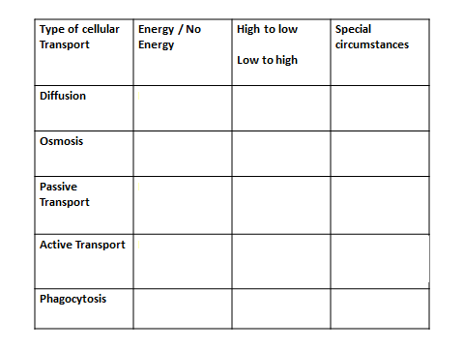

- Red Onion in tap water
Draw

- Red Onion in distilled water starting to rehydrate
Draw

- Red Onion eventually goes back
Draw

