December Notes: Day 3 The Immune System
Name: Period: Date:
Aim: How does the Immune system protect us from disease?
Do now: answer these review questions in your notebook
- What is the name of the cells that makes up the nervous system?
- What is the name of the type of organs that make hormones?
- What type or organic molecules are neurotransmitters and hormones? (they are the same)
- What are 2 differences between the signals of the nervous system and the endocrine system?
Why an immune system?
- Humans and animals must defend themselves against
: Examples: , ,
Examples: , ,
: Examples: , ,
Examples: , ,
- Cancer cells: body cells
How do invaders enter the Body?
- Points of entry: , , , ,
- How does the body defend? ,
How are invaders recognized?
chemical name tags on the of every cell
Lines of defense
- 1st line: → broad, defense i.e. “walls & moats”
  - & membranes
- 2nd line: patrol → broad, defense i.e. “patrolling soldiers”
  - phagocyte (eating) WBCs
- 3rd line: system → , immunity i.e. “elite trained units”
  - lymphocyte s & : B & T cells
1st line: Barriers
- non-specific defense
- external barriers
- skin & mucus membranes
excretions: , , , ,
2nd line: , range patrols
- Patrolling cells
  - invaders that get through the skin
  - recognize invader by reading :surface name
- phagocyte cells: → “big eaters”
Lymph system
- of white blood cells & traps “foreign” invaders
- vessels: (intertwined amongst blood vessels)
- node
- 2nd system
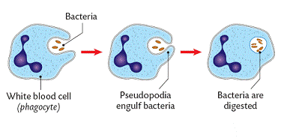
Phagocytes: blood cells that

Why do injuries swell?
Inflammation → cells release chemical signals called
Functions of histamines include:
- blood flow
- more blood cells to fight bacteria
- more blood cells & factors to
Fever
Occurs when a local response is not enough
- full body to
- body
- higher temperature helps in
- growth of
- helps
- up of tissues
3rd line: Lymphocytes
- defense
- responds to specific
- specific foreign
- white blood
  - &

B cells & antibodies
- B cells: white blood cells that invaders in blood
- mature in
Patrolling : make against invader immediately
B cells: remembers invader. Can make antibodies the next time. you from getting disease more than once
Antibodies
made by B cells that invaders in the blood so can eat them
- tag says “this is an ” → biological “ ”
- attaches to of
Vaccinations
- to version of
- immune system to produce to invader
- response if exposure
- Most successful against diseases
Protecting you from disease
- Vaccinations
  - Advantage → don’t get illness, immunity (produce for life), works against many
& bacteria
  - Disadvantage → not possible against invaders
- Breastfeeding: mother’s milk gives baby & keeps baby healthy`

What if the attacker gets past the B cells in the blood & infects some of your cells?
You need trained to kill off these infected cells!
T cells
- T cells mature in
- cells →sound the for rest of system
- cells → infected cells
- cells → invader & reacts against it again
Attack of the Killer T cells
- Killer T cells cells
- T cell to invaded cell

- cell membrane of infected cell
- cell
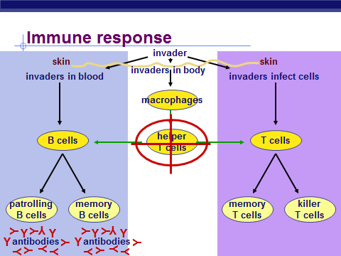

Diseases of the immune system
:
- infects cells
- helper T cells can’t rest of system
- body doesn’t hear the
:
- system is
- by other diseases
- from invading or cancer
Curing you of disease
Antibiotics = medicine
- Advantage → kill that have successfully you, make you well after being sick
- Disadvantage→ use only sick, only good against bacteria, possible development of by bacteria (if don’t use correctly), can get sick again
Immune system malfunctions
Auto-immune diseases
- immune system own cells
  - → attack many different cells
- rheumatoid → causing damage to & bone
- → -making cells of attacked & destroyed
- multiple →T cells attack myelin sheath of & spinal cord .Fatal
Immune system malfunctions
- Allergies → to compounds
Cause allergies
- proteins on
- proteins from mites
- proteins in saliva
- body thinks they are attackers
